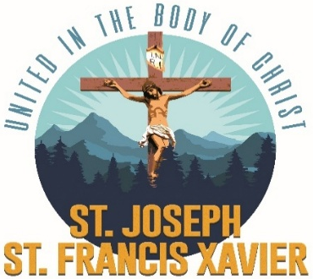
Teen Confirmation Preparation
Information & Policies
“Now when the apostles in Jerusalem heard that Samaria had accepted the word of God, they sent them Peter and John, who went down and prayed for them, that they might receive the holy Spirit, for it had not yet fallen upon any of them; they had only been baptized in the name of the Lord Jesus. Then they laid hands on them and they received the Holy Spirit.” (Acts 8:14-18)
General Information & Requirements
- Teens must be baptized, in 7th to 12th grade, and desire to receive the Sacrament of Confirmation.
- Teens must be active in the Youth Group for one year, prior to registering for Confirmation prep.
- Teens and their families must be registered at either parish: St. Joseph or St. Francis Xavier.
- Teens must faithfully attend the Thursday Confirmation Prep Classes from 6:00 - 8:00 pm.
*Three absences are permitted.
*Emergencies and/or illnesses are taken into consideration provided the family alerts the Confirmation Coordinator.
- Teens will be assigned a Mass reflection sheet and homework questions every week.
- Each teen will need to select a saint name and write a report on that saint per the saint report outline.
- Teens, parents, and sponsors must attend the scheduled Sacrament of Confirmation Mass. This Mass will take place sometime in May. The date, time, and location are assigned to us by the Archdiocese of Portland. The dates should be released in early November.
- A class fee of $60.00 is due by the first day of class or on the day of the registration. The class fee covers the cost of materials, books, and snacks. Payment plans and/or scholarships are available upon request.
- Teens are required to attend a Confirmation Retreat. The retreat cost is not included in the class fee. Payment plans and/or scholarships are available upon request.
- A copy of the teen’s sacramental record is needed by December 4th.
If the teen was baptized at another parish… parents need to contact the church and request a “Sacramental Record with notations.” Send the record to the address below:

Attn: Erik Castillo
St. Joseph / St. Francis Xavier Catholic Church
800 W Stanton St.
Roseburg, OR 97471
- An eligible sponsor must be selected by December 4st. (see “Sponsor requirements” page )
- Parents and sponsors are required to attend several classes with their teen(s). A schedule will be issued well in advance.

Confirmation Prep classes meet on Thursdays from 6:00 - 8:00 pm in the Youth Center. Classes begin the first Thursday of October and end in mid-late May.

