Candidate’s Name: ____________________________________ Name of the Church: _________________
Sunday of the Liturgical season: ________________________ Date of Mass attended: _____________
Time: ______________ Name of the Priest that celebrated Mass: _________________________________
- . Readings of the Mass
- First Reading (OT): What message did I understand?
______________________________________________________________________________________________________________________________________________________________________________________________________________________________________________________________________________________________________
- Psalm: What verse touched me the most?
______________________________________________________________________________________________________________________________________________________________________________________________________________________________________________________________________________________________________
- Second Reading (NT): What is it teaching me?
______________________________________________________________________________________________________________________________________________________________________________________________________________________________________________________________________________________________________

- Gospel: What did Jesus do or say today?
______________________________________________________________________________________________________________________________________________________________________________________________________________________________________________________________________________________________________

2. Homily
- Main idea from the priest’s homily:
______________________________________________________________________________________________________________________________________________________________________________________________________________________________________________________________________________________________________

3. Applying the Word of God
- What is God inviting me to change or improve?
______________________________________________________________________________________________________________________________________________________________________________________________________________________________________________________________________________________________________

4. Moments of the Mass
- A part of the Mass that helped me pray deeply:
____________________________________________________________________________________________________________________________________________________________________________________________________________________________________________________________
- If necessary, see for help in completing this sheet.
1) www.bible.usccb.org 2) www.ewtn.com / Catholicism / daily-readings
3) www.wordonfire.org /resources/homily/
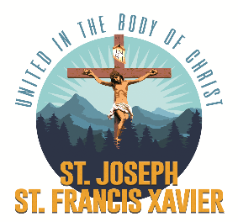
Have the Priest who was celebrated the Mass sign here: _____________________________

